PLAYON SPORTS

“COLD STEEL” STYLE GUIDE

### LAST UPDATED NOVEMBER 24, 2012

# FONTS

The only font used in the entire package is Eurostile Bold. This font should have been included in your graphics package for Duet, XPression or LiveText.

# PROJECT RESOLUTION

All graphics and creative were built natively at 1920x1080 and will support up to 1080p HDTV shows. Most systems such as Duet, XPression and LiveText support working with projects at their native resolution while outputting a different resolution to the switcher if necessary.

All graphics were also built to be used in a 16:9 HDTV show, but are designed with 4:3 safe in mind. As such, broadcasts airing the show as an edge-cropped SD down-conversion should be okay.

Note that because the graphics were designed with both HDTV and web streaming as the primary delivery method, many graphical elements are much closer to the edge of the screen than would typically be seen in a natively SD show. This is okay. The graphics have been tested in an HDTV environment and are appropriately positioned as-is. **Please do not adjust the position of elements on screen unless directed to by your producer**. If you have a concern about the position of elements on screen, please consult with the director or producer, or contact a PlayOn! Sports representative.

# TITLES AND COLORS

### Capitalization

Throughout the graphics package, a mixture of ALL CAPS and Title Case has been used. Generally, the main title of the graphic is presented in ALL CAPS, while any secondary or subtitle is presented in Title Case. Qualifiers are generally also in ALL CAPS. For example:

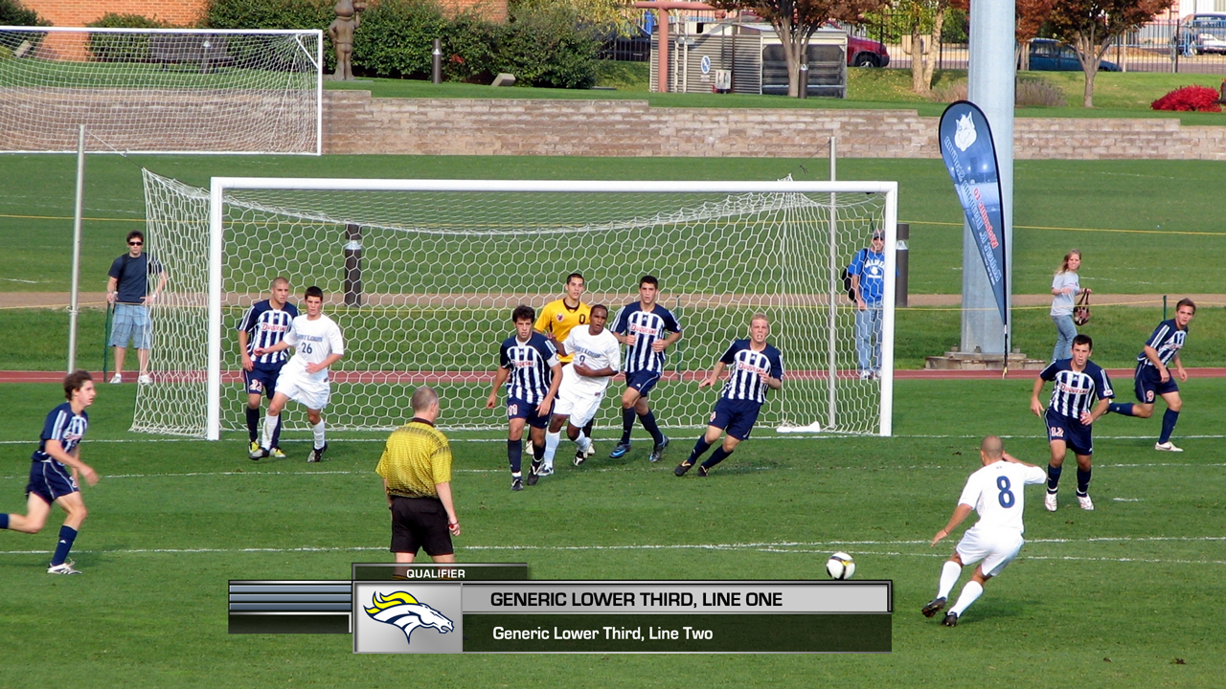

Figure ALL CAPS TITLE; Title Cased Subtitle

### Colors

Although there a few places exempt from the rule, most text is BLACK, WHITE, LIGHT GREY, or GOLD. In the example above, line one is black, line two is white. Subtitles and secondary information may often be presented in light grey, such as in this example:

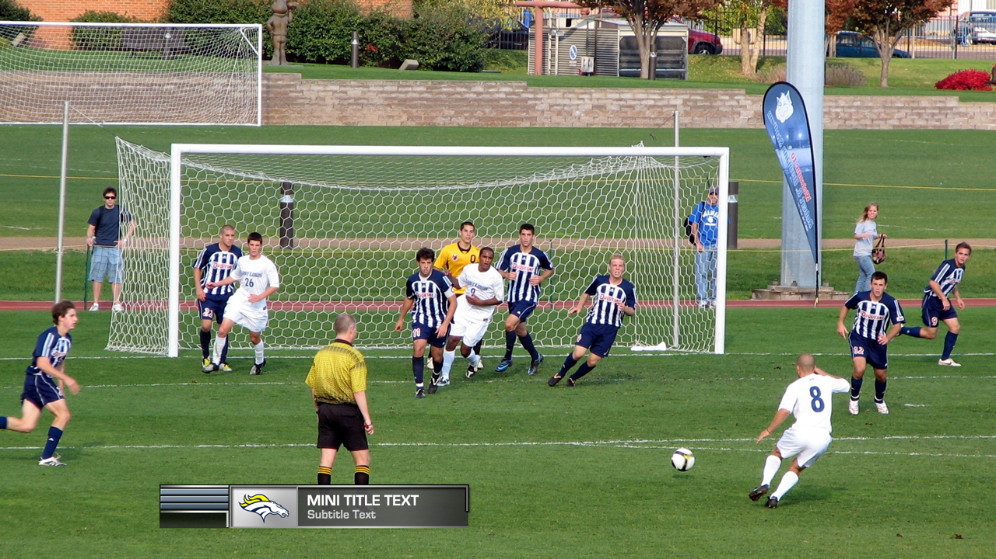

Figure Subtitle is in light grey text

### Presentation of Stats or Other Data

Additionally, when presenting columnar or statistical data, the category of data should be presented in gold while the values should be presented in white. For example:

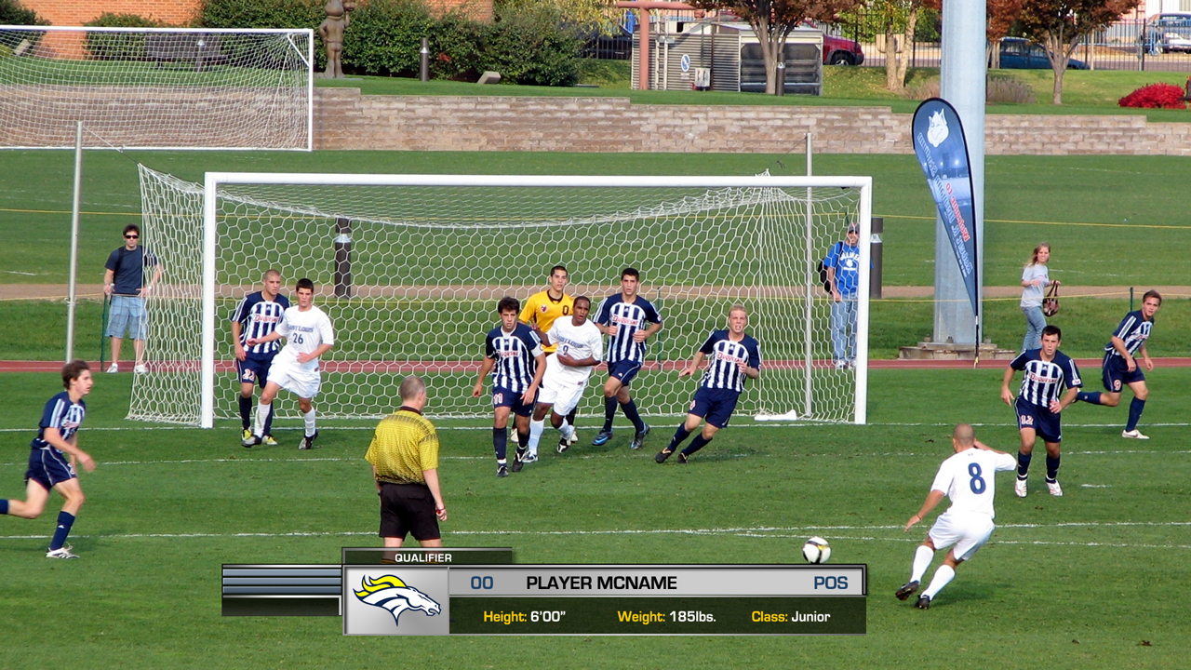

Figure Categories of data are gold, while the data itself is white

Note that the gold text is still Title Cased, as appropriate for this line of text. For columnar data, however, you should ALL CAPS the headers, but otherwise use Title Case for the data:

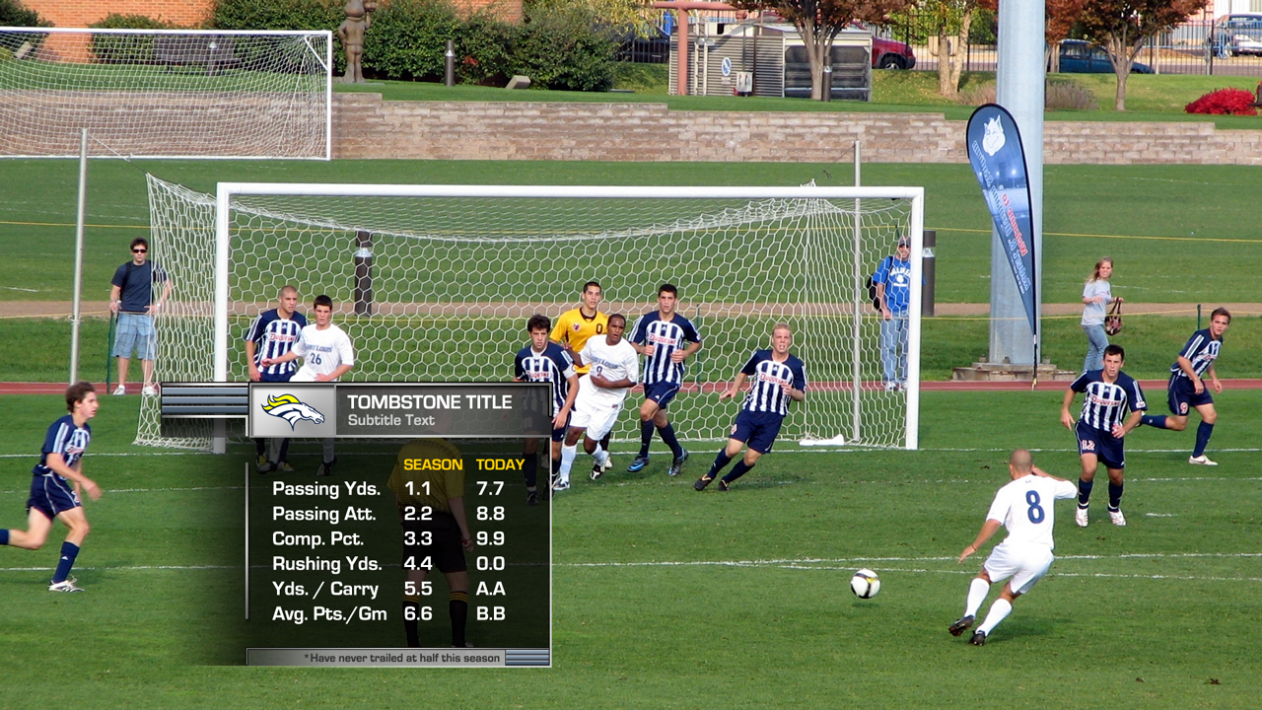

Figure Columnar data headers are presented in gold

EXAMPLES OF AVAILABLE TEMPLATES

COMMENTATORS 5

COPYRIGHT / CREDIT 6

FAN OF THE GAME 7

[FULL SCREEN (GENERIC)](#_FULL_SCREEN_(GENERIC)) 8

FULL SCREEN (STATS) 9

KEYS TO THE GAME 11

LOWER THIRDS 12

SCHEDULES AND RECAPS 13

[SCOREBOARD](#_SCOREBOARD_(TEAM_SPORTS)) 14

SPLIT SCREENS AND COMPARISONS 15

[STARTING LINEUPS (FULLSCREEN)](#_STARTING_LINEUPS_(FULLSCREEN)) 16

[STARTING LINEUPS (TOMBSTONE)](#_STARTING_LINEUPS_(TOMBSTONE)) 17

STATS BY QUARTER 18

TALENT ID 19

TITLE CARD 20

TOMBSTONE 21

# COMMENTATORS

Use this graphic to display the announcers names when they are not on screen.

The “qualifier” tab is optional, but the recommended text would be “COMMENTATORS” or “VOICE OF”.

Names of announcers or commentators should be ALL CAPS.

# C:\Users\jcarlson\Dropbox\PlayOn! Cold Steel GFX\PROOFS\COMMENTATORS.png

# COPYRIGHT / CREDIT

Used with the PlayOn! Sports logo and the text on two lines:

**© 2012 PlayOn! Sports Network  
All Rights Reserved**

Note that line one is Title Cased to preserve the proper capitalization of **P**lay**O**n! **S**ports and in all-white text; line two is also Title Cased (as usual) and in light gray text.

This graphic can also be used to thank sponsors, partners, networks, or provide other business credits at the close of the show. Use the credited party’s logo in this case. If the text is too long for a single line, the second line may use the same white text as the first.

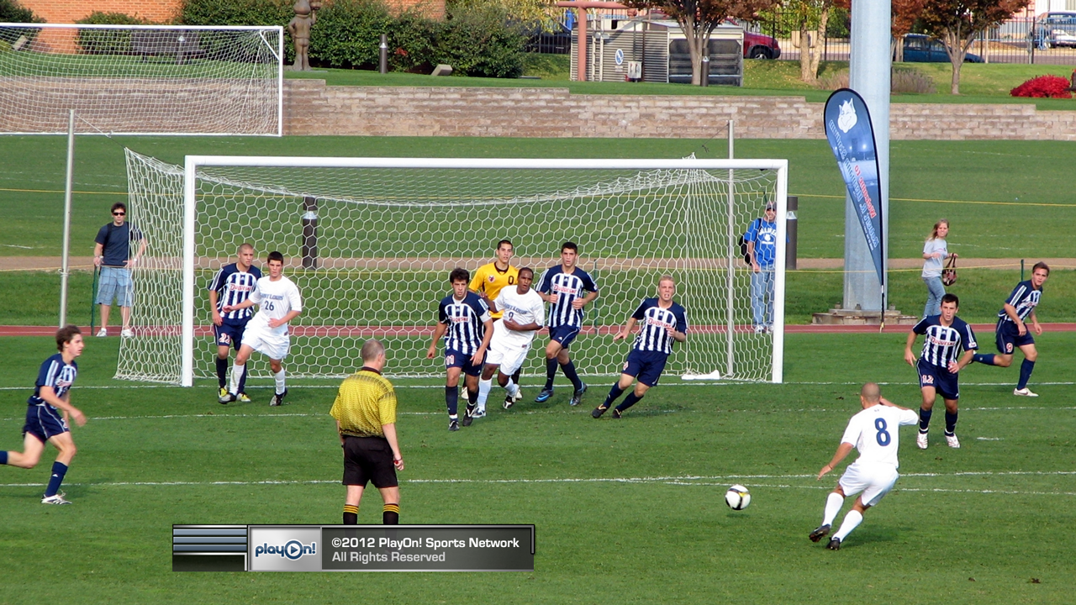



Figure Special Thanks credit

# FAN OF THE GAME

Use the “Mini Title” or “1Line L3” template with the logo box hidden.

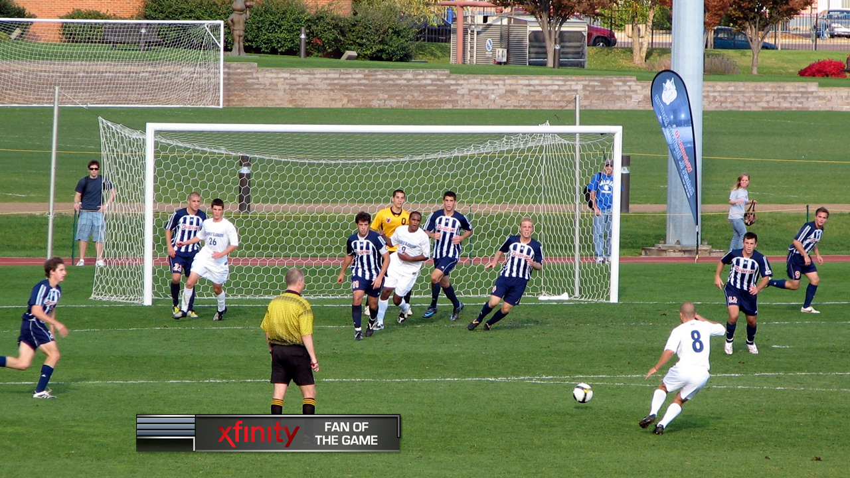

# FULL SCREEN (GENERIC)

There are no elements of the show requiring this template, but it is available for ad-hoc graphics or presentation of large amounts of information. Use at your discretion.

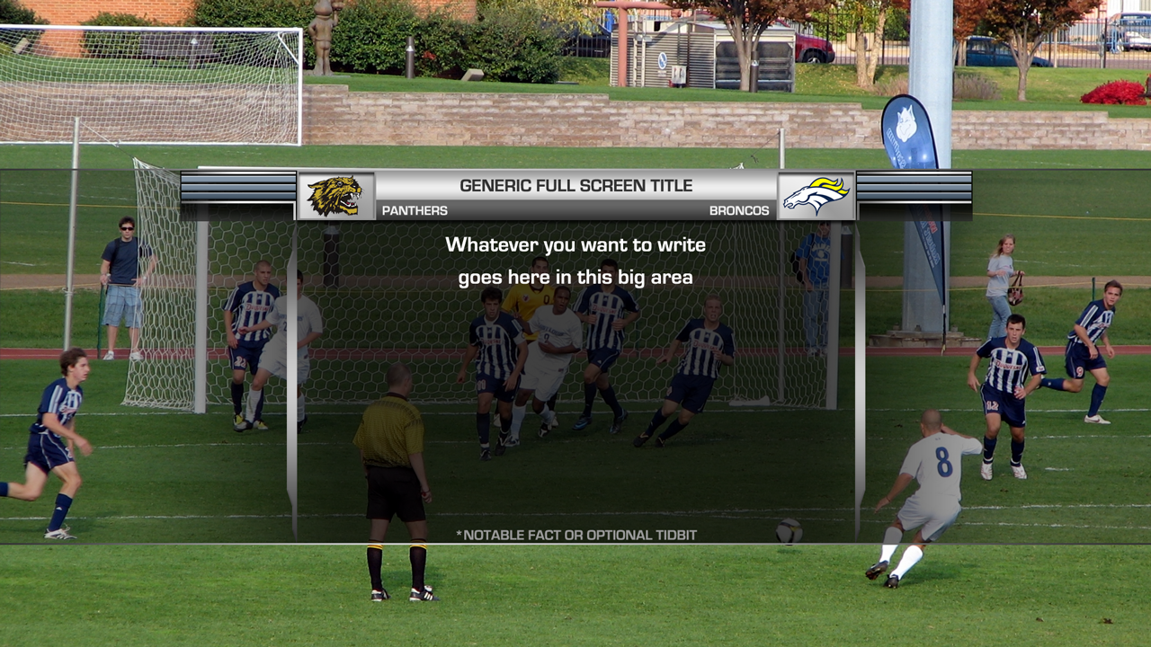

# FULL SCREEN STATS AT HALFTIME

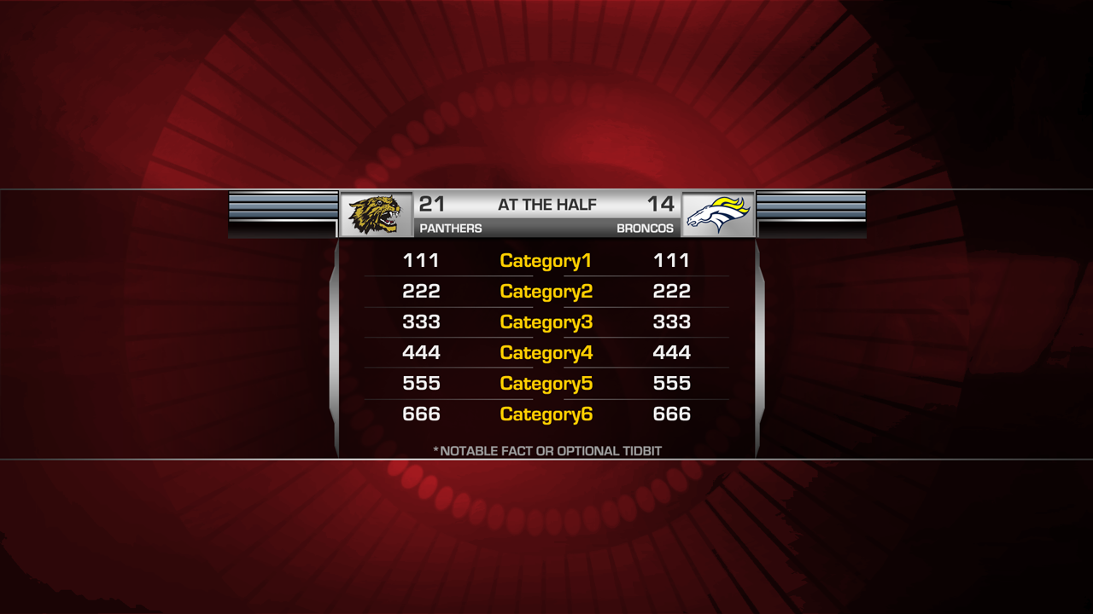Display stats at halftime. For quarter stats, use the Tombstone stats comparison template shown later in the document.

For less than six categories of stats, remove the last line and the divider between lines and increase vertical spacing between lines to fill the box as best as possible.

For four or fewer categories of stats, consider using the Tombstone stats comparison template instead.

A Title Bar with sponsor logo may be added if this inventory has been sold. The sponsor logo and/or sponsor text should be kept within the Title Bar area, as shown below.

The full screen stats should be run over a full animated background if available, or a scenic wide beauty shot otherwise.

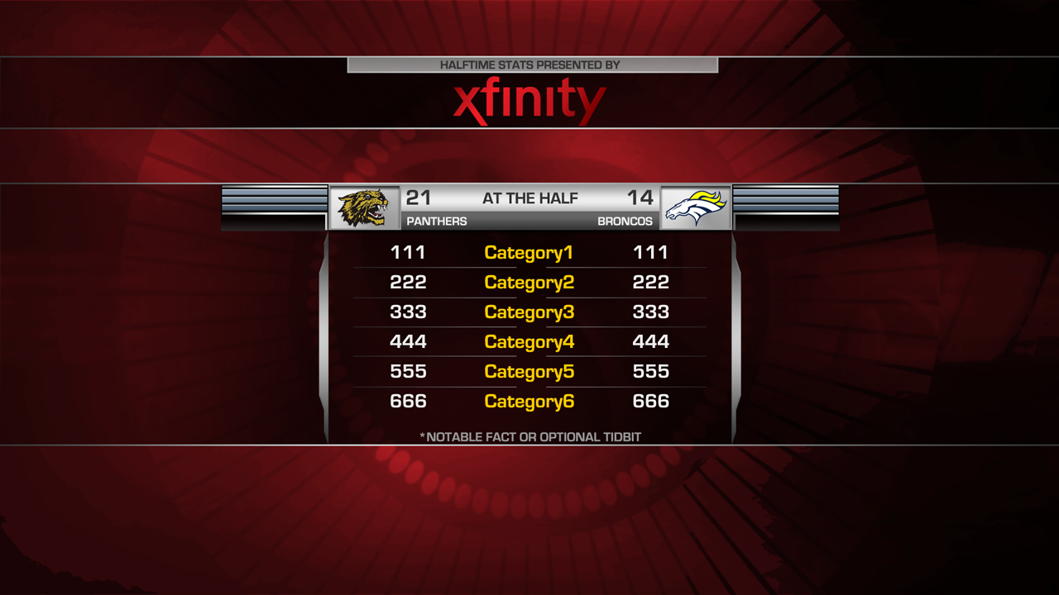

Figure Title bar text: "Halftime Stats Presented By"

# KEYS TO THE GAME

Template used to list up to three bulleted keys for each team. Note that the bullets may appear in either light grey or gold, if highlighting a particular item is necessary.

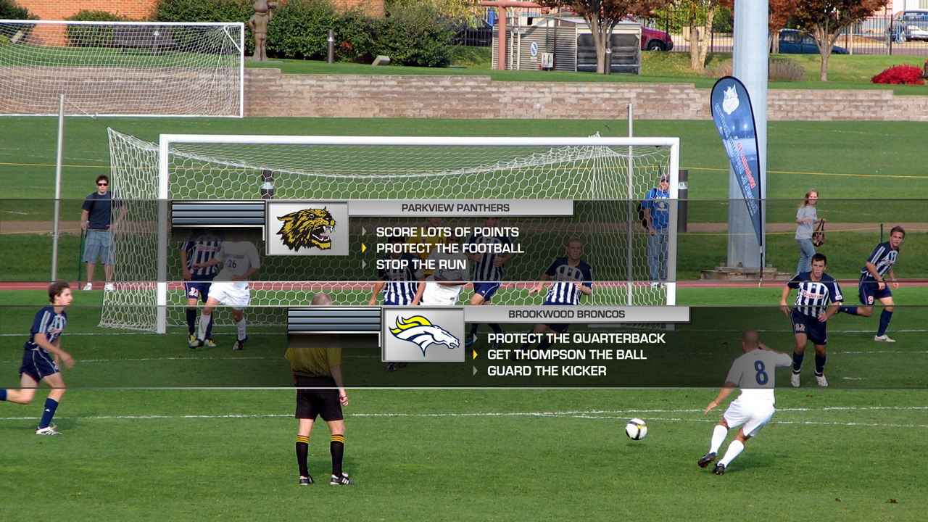

Like the Full Screen Stats, sponsorship inventory is available for this item and is displayed in the optional title bar. Below is an example of a pair of sponsor logos used in the Tennessee Blue Cross Bowl.

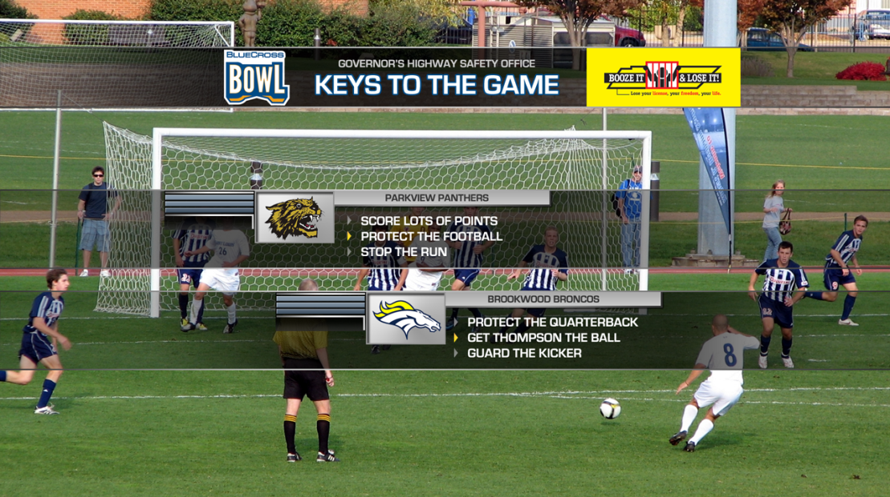

Figure Governor's Highway Safety Office sponsors Keys to the Game

# LOWER THIRDS

Most lower thirds have optional logo boxes and qualifier tabs. Use these at your discretion. Note the CAPITALIZATION of line one and the Title Casing of line two.

Lower thirds are available in one-, two- and three-line variations, pictured here in a variety of use cases.

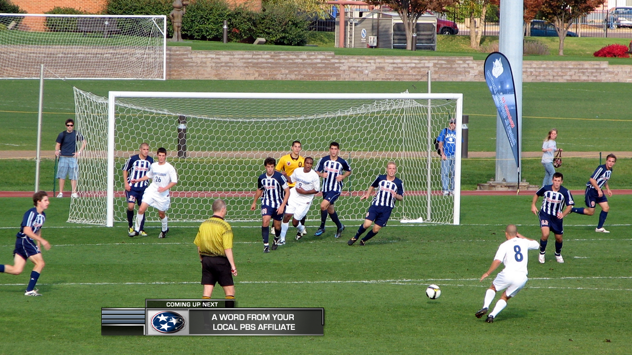

Figure One line lower third; text may physically wrap to a second line



Figure Player bio font as two-line lower third



Figure Generic two-line lower third for promos and drop-ins

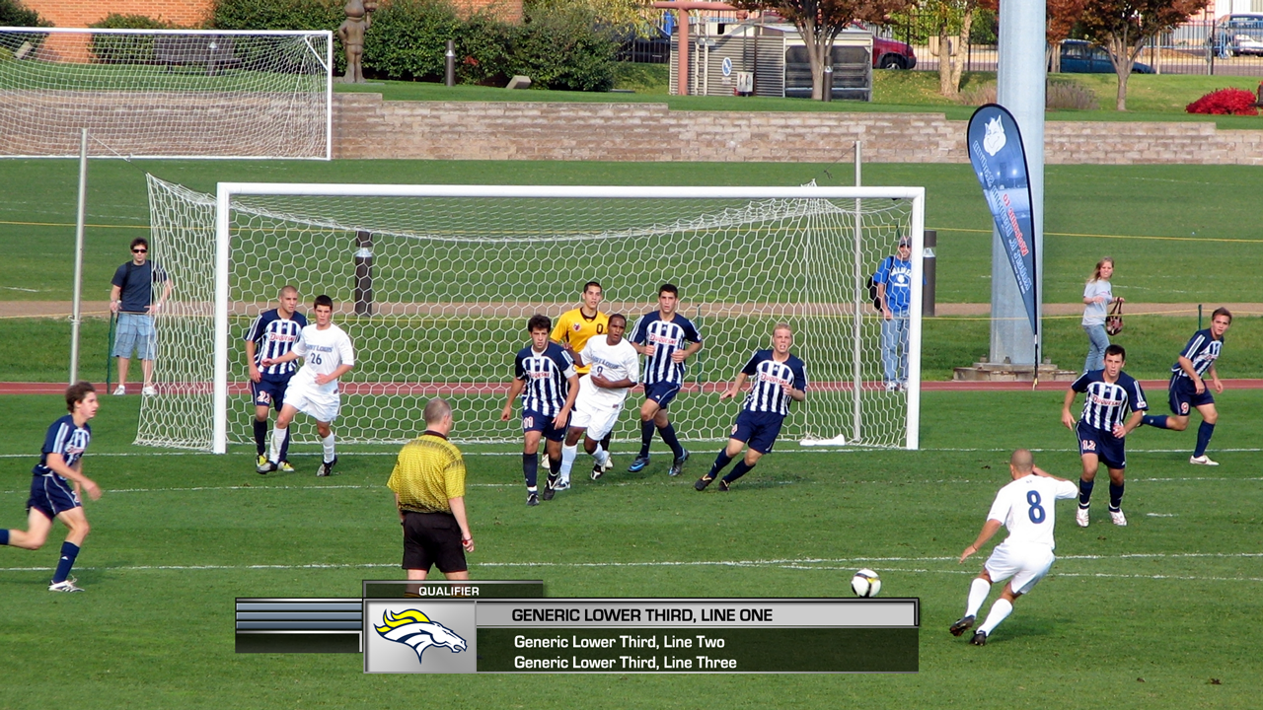

Figure Generic three-line lower third can be used for promos and drop-ins

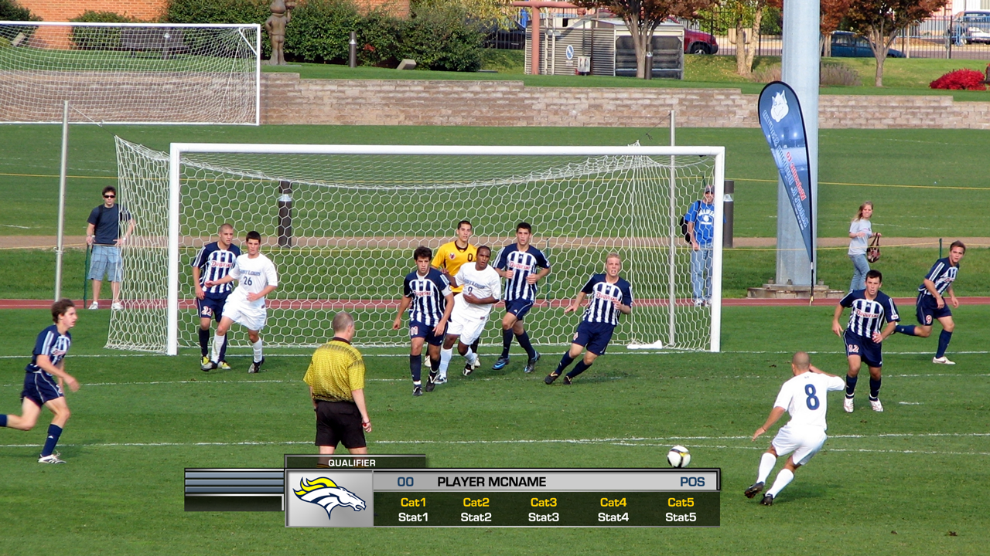

Figure Player stats as three-line lower third support 3-5 categories of stats



Figure Mini Title can be used as a reduced-footprint two-line lower third

# SCHEDULES AND RECAPS

For multi-game coverage, these templates can be used to showcase upcoming games or to recap games that happened earlier in the coverage. Available in one-, two- and three-game versions. Sponsor and network logos may be placed in the title bar or omitted if desirable. The entire title bar may also be hidden or disabled.

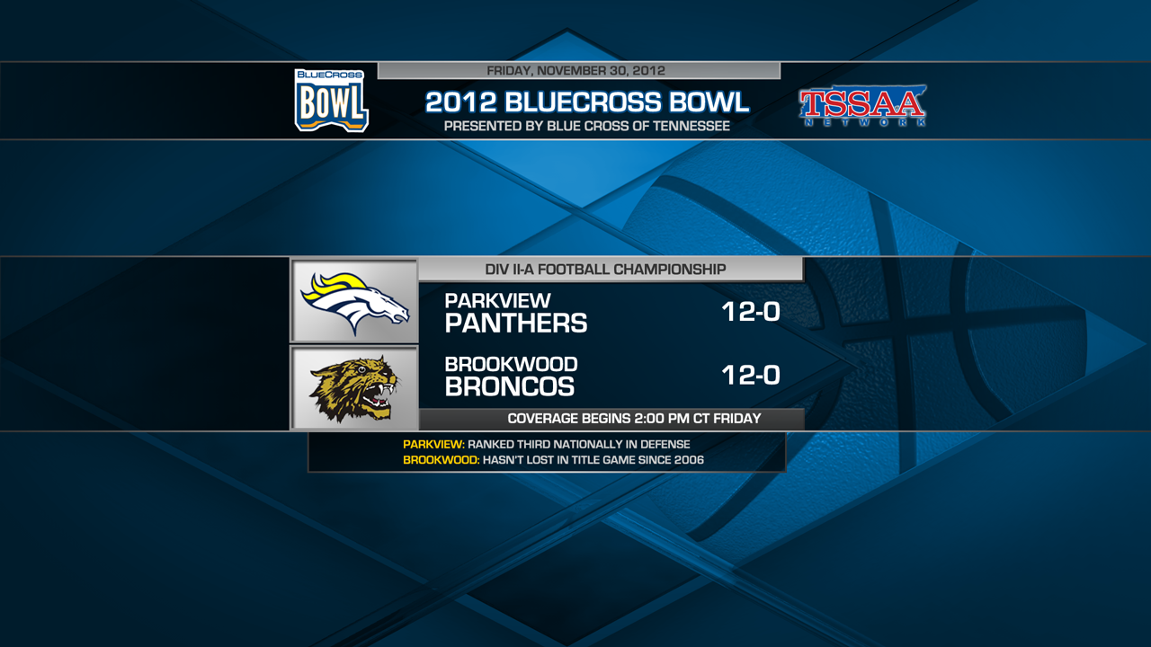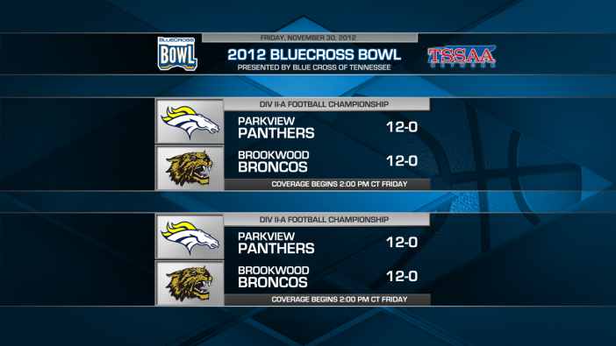 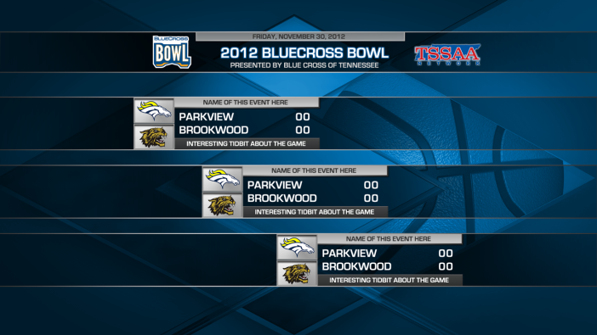

Figure Two-game schedule (left) and three-game recap (right)

# SCOREBOARD (TEAM SPORTS)

Used into or out of break to display the current scores, game time and period. The game clock may be hidden if the current value is at 0:00. Displays the network logo to the right of the scores. Note that this scoreboard is appropriate only for team-vs.-team matchups. Tournaments or multi-team events should use an alternate template.

An alternate version is available that includes a title sponsor, as shown here:

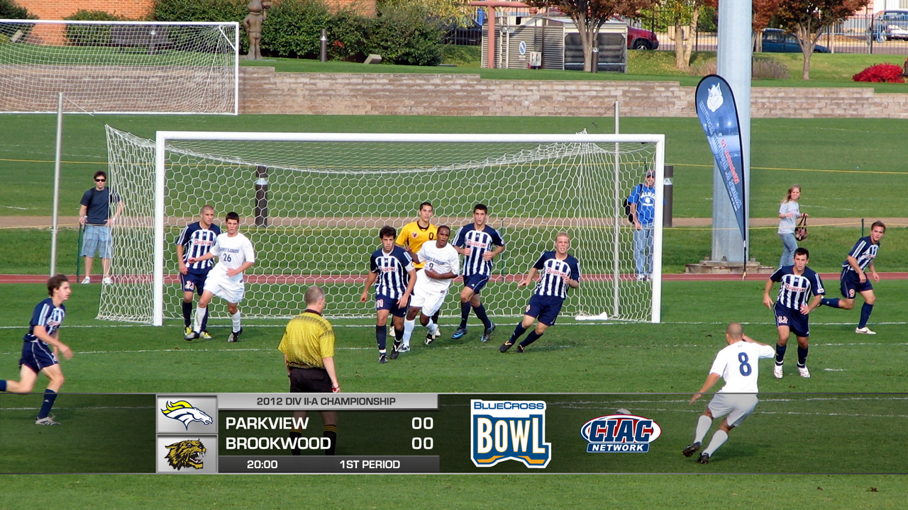

Figure Scoreboard to break with title sponsor

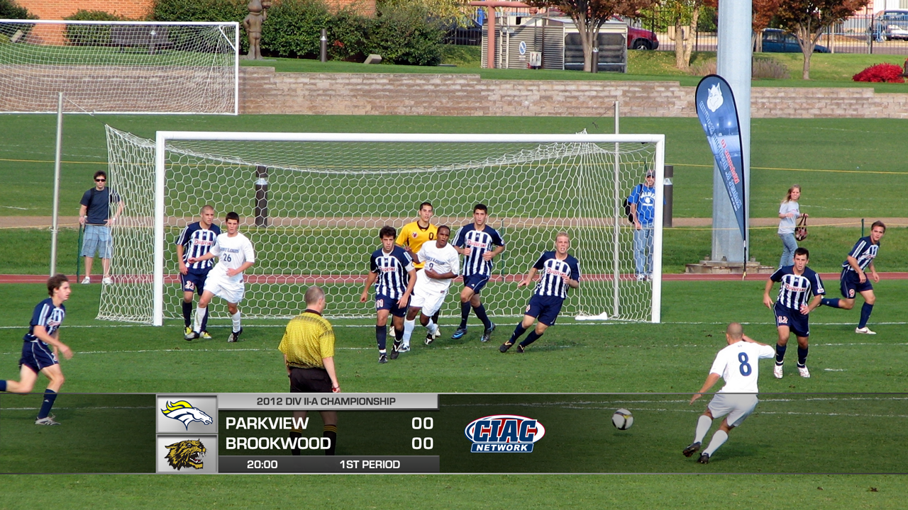

# SPLIT SCREEN

Used at discretion of director or producer. Font operator may add title sponsor logos and left/right lower thirds for visual identification and comparison.

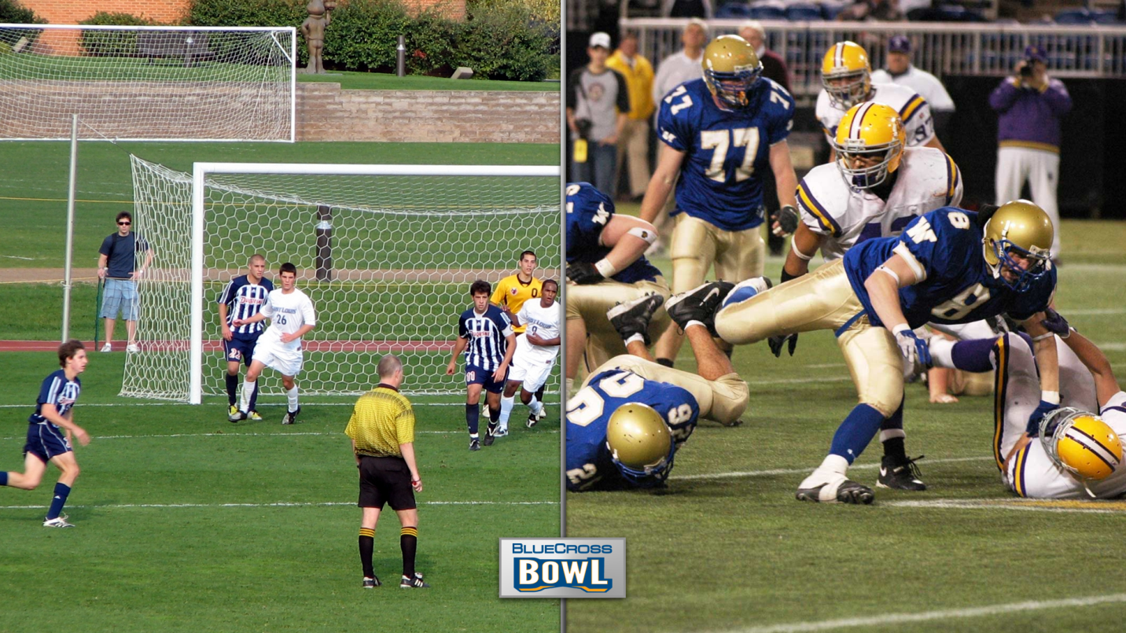

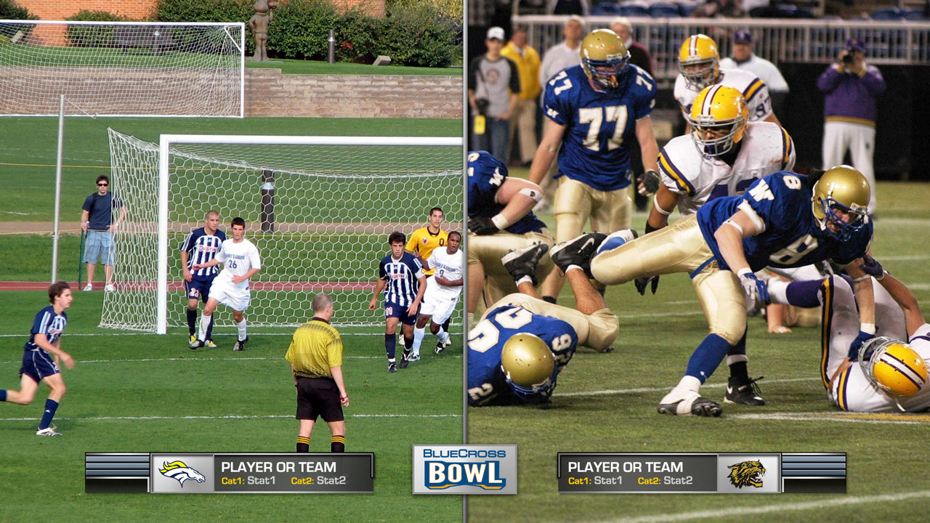

Figure Split screen with player or team comparison

# STARTING LINEUPS (FULLSCREEN)

Use this template to quickly display all starters for offense of defense of each team. Preference is given, however, to the Tombstone lineups listing 4-5 players at a time. See the next section.

**NOT PICTURED:** A Title Bar is available in this template in the event that this inventory has been sold. See “KEYS TO THE GAME” for an example of the title bar.

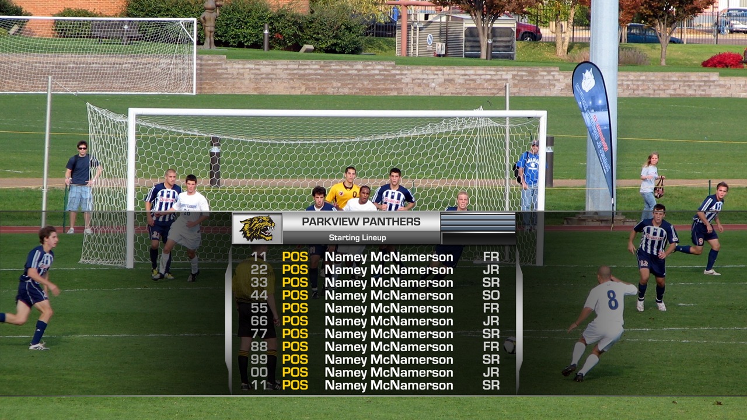

# STARTING LINEUPS (TOMBSTONE)

In this mode of presentation, lineups are grouped by position: quarterback, offensive line, backs and receivers, defensive line, linebackers, and secondary. Each group gets its own font for a total of six pages per team. Although this style requires more fonts to be cycled through, the information is much clearer and easier to read and is preferred, when possible, over the full screen layout.

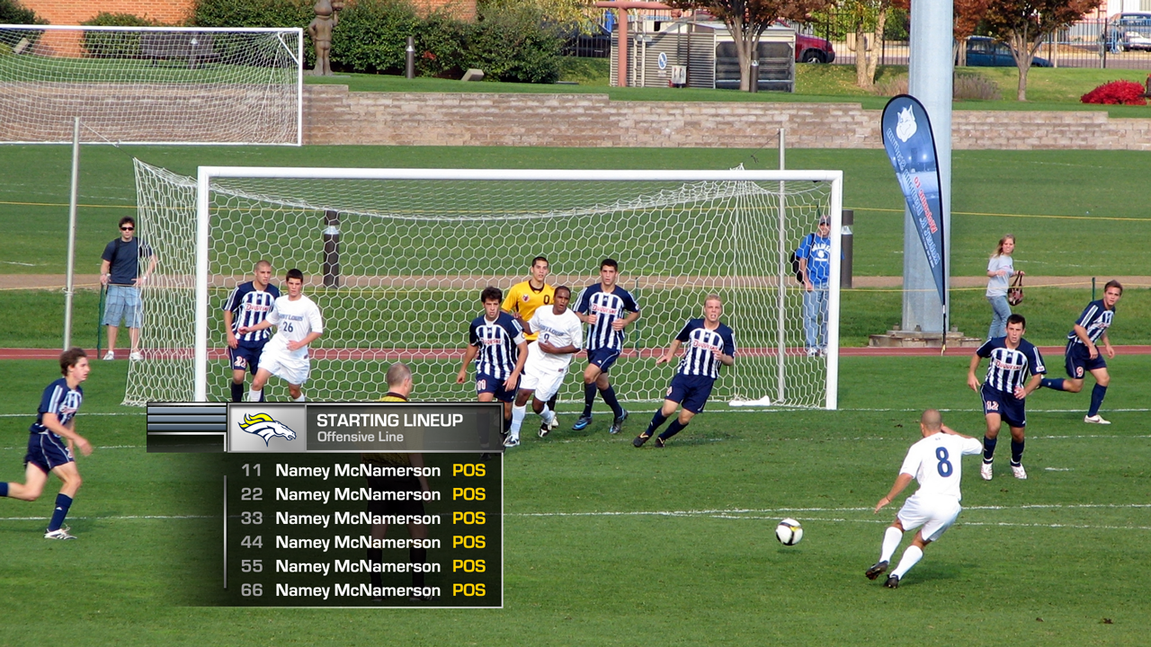

# STATS BY QUARTER

Used to compare values over several periods, such as score-by-quarter or rushing yards per quarter. Used at the discretion of the font coordinator or statistician.

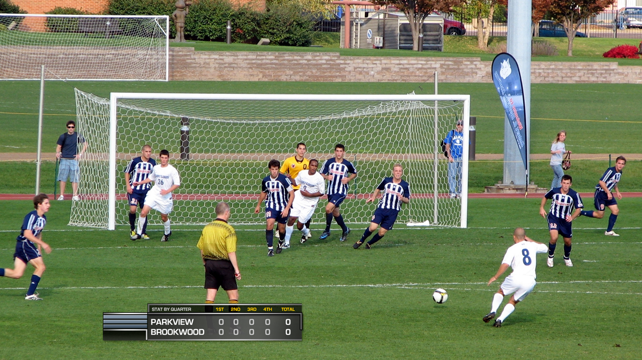

# TALENT ID

Used to font the announcers or commentators while on-screen either on the field or in the booth. Available in both two- and three-man layouts. An optional event name bar is available to identify the event (or broadcast network or sponsor, if preferred).

An alternate version is available to accommodate sponsor or network logos, but this layout supports only two names due to space constraints.

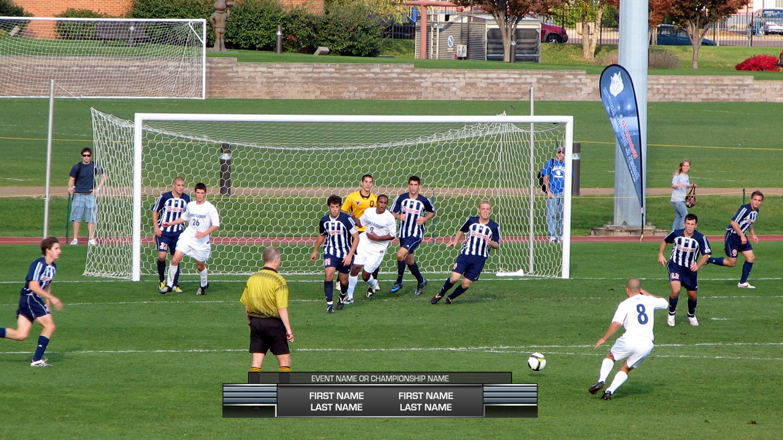

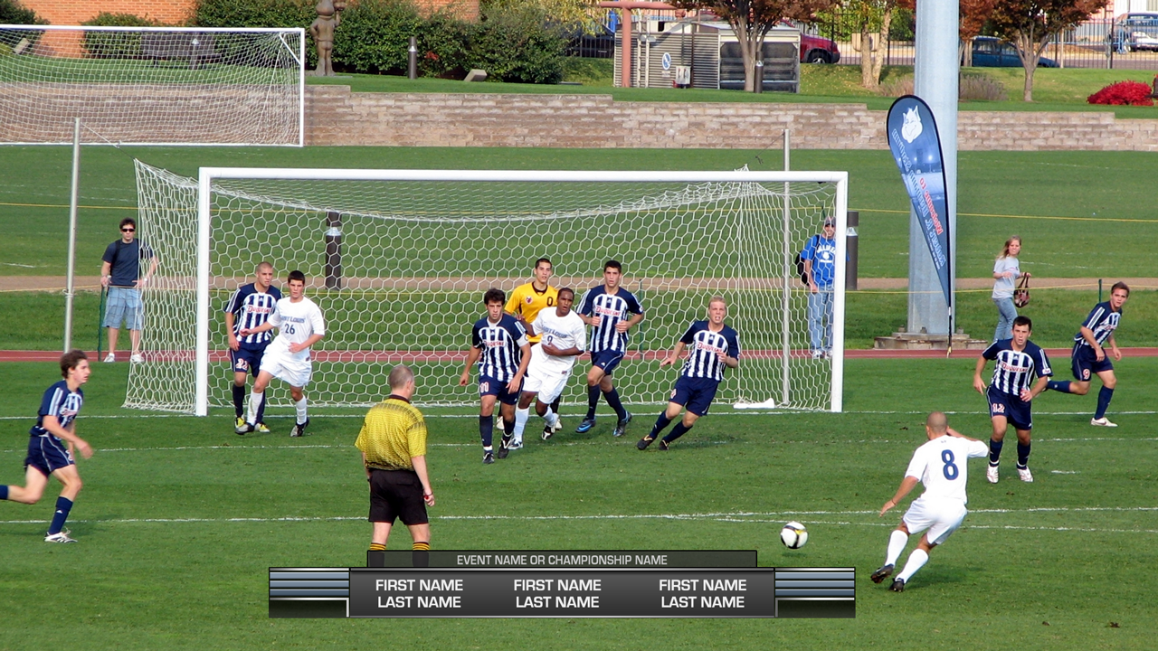

Figure Three-man talent ID

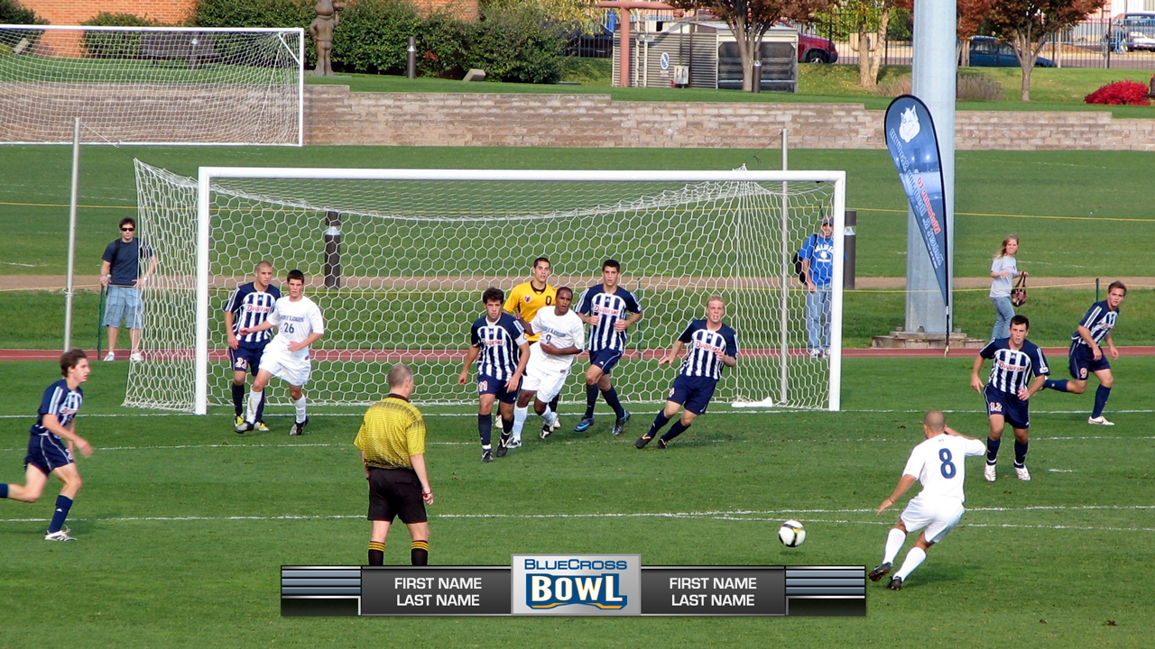

Figure Two-man talent ID with sponsor or network logo

# TITLE CARD

Used at the top of the show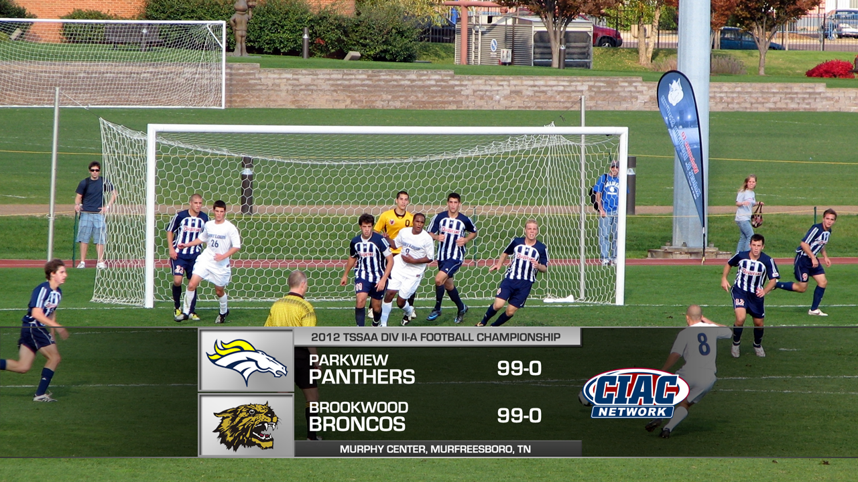 during the open. The event title should appear in the top bar and the venue name, city and state in the bottom bar.

Additionally, the broadcast network logo should appear to the right of the teams. Use your judgment and/or Photoshop to treat the network logo to ensure it appears large enough and is legible.

### TITLE SPONSOR AND EVENT-SPECIFIC LOGOS

For events with a title sponsor or an event-specific logo, such as BlueCross/BlueShield, a second version of the title card is available that includes an area of variable size above the title card for placement of this logo. Adjust the height of this logo area as necessary to best fit the logo. See example.

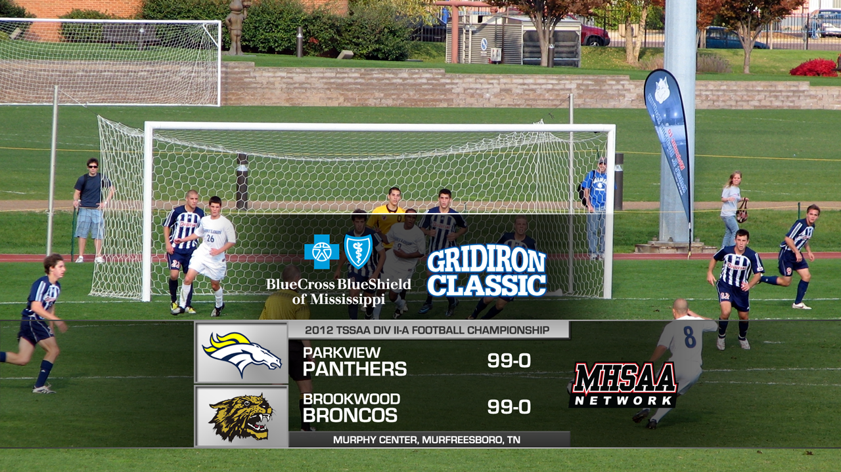

Figure 19 Title card with event-specific logo

# TOMBSTONE

Used for a variety of purposes, from half-time stats (see dual-logo version), team stats, long promos and drop-ins, and more, the Tombstone is one of the most versatile templates in this package.

A “short” version is available for drop-ins or promos too long for a generic lower third but that do not require the full-height Tombstone (below, right). Usage is at the discretion of the producer, director, or font-coordinator. The logo box is always optional, but should show the team, sponsor, or network logo.

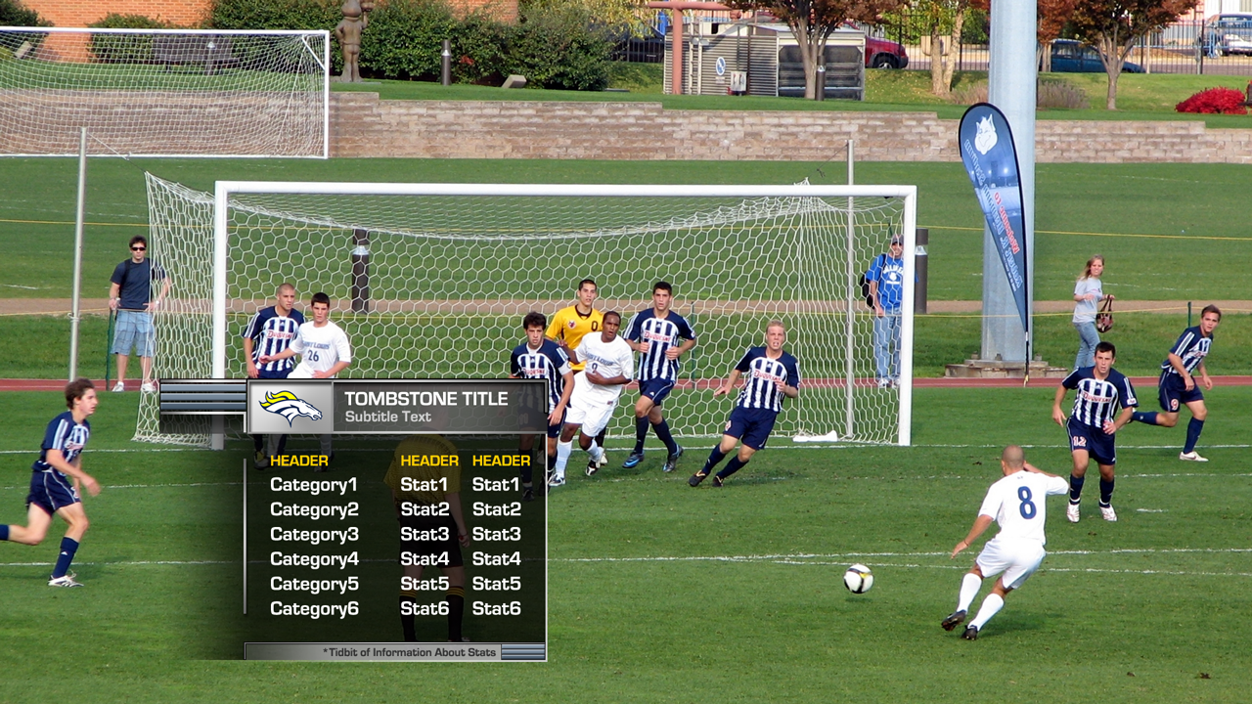

 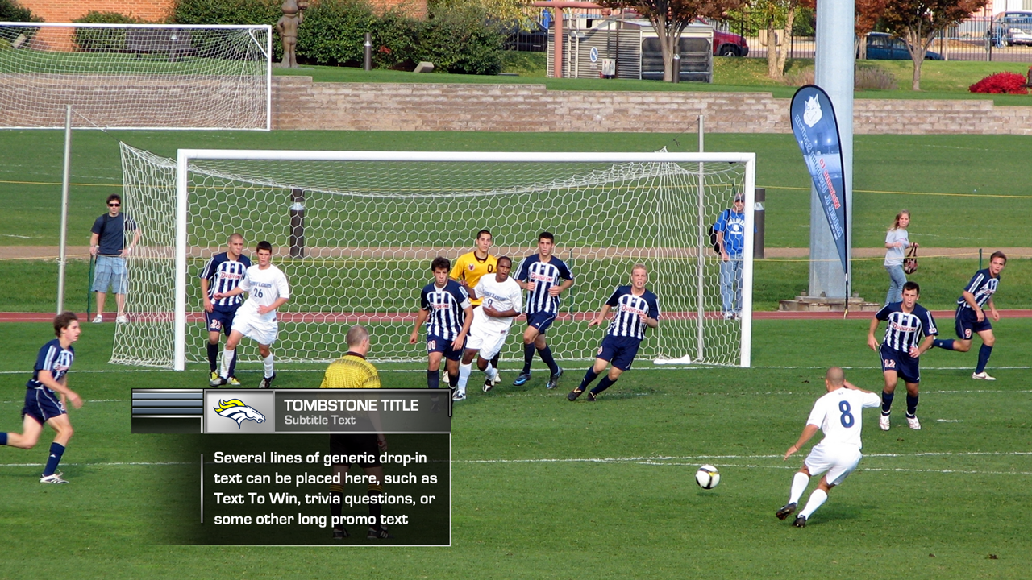

Figure 20 Tombstone for team stats (left) and long promo text or drop-ins (right)